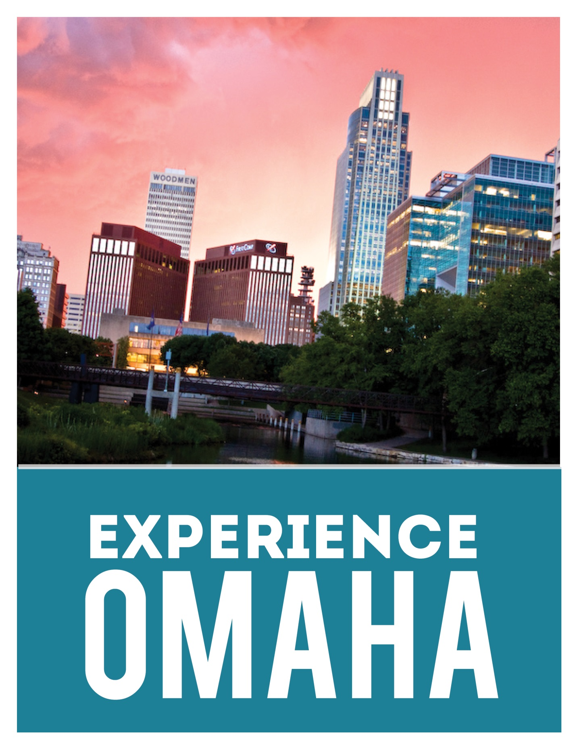

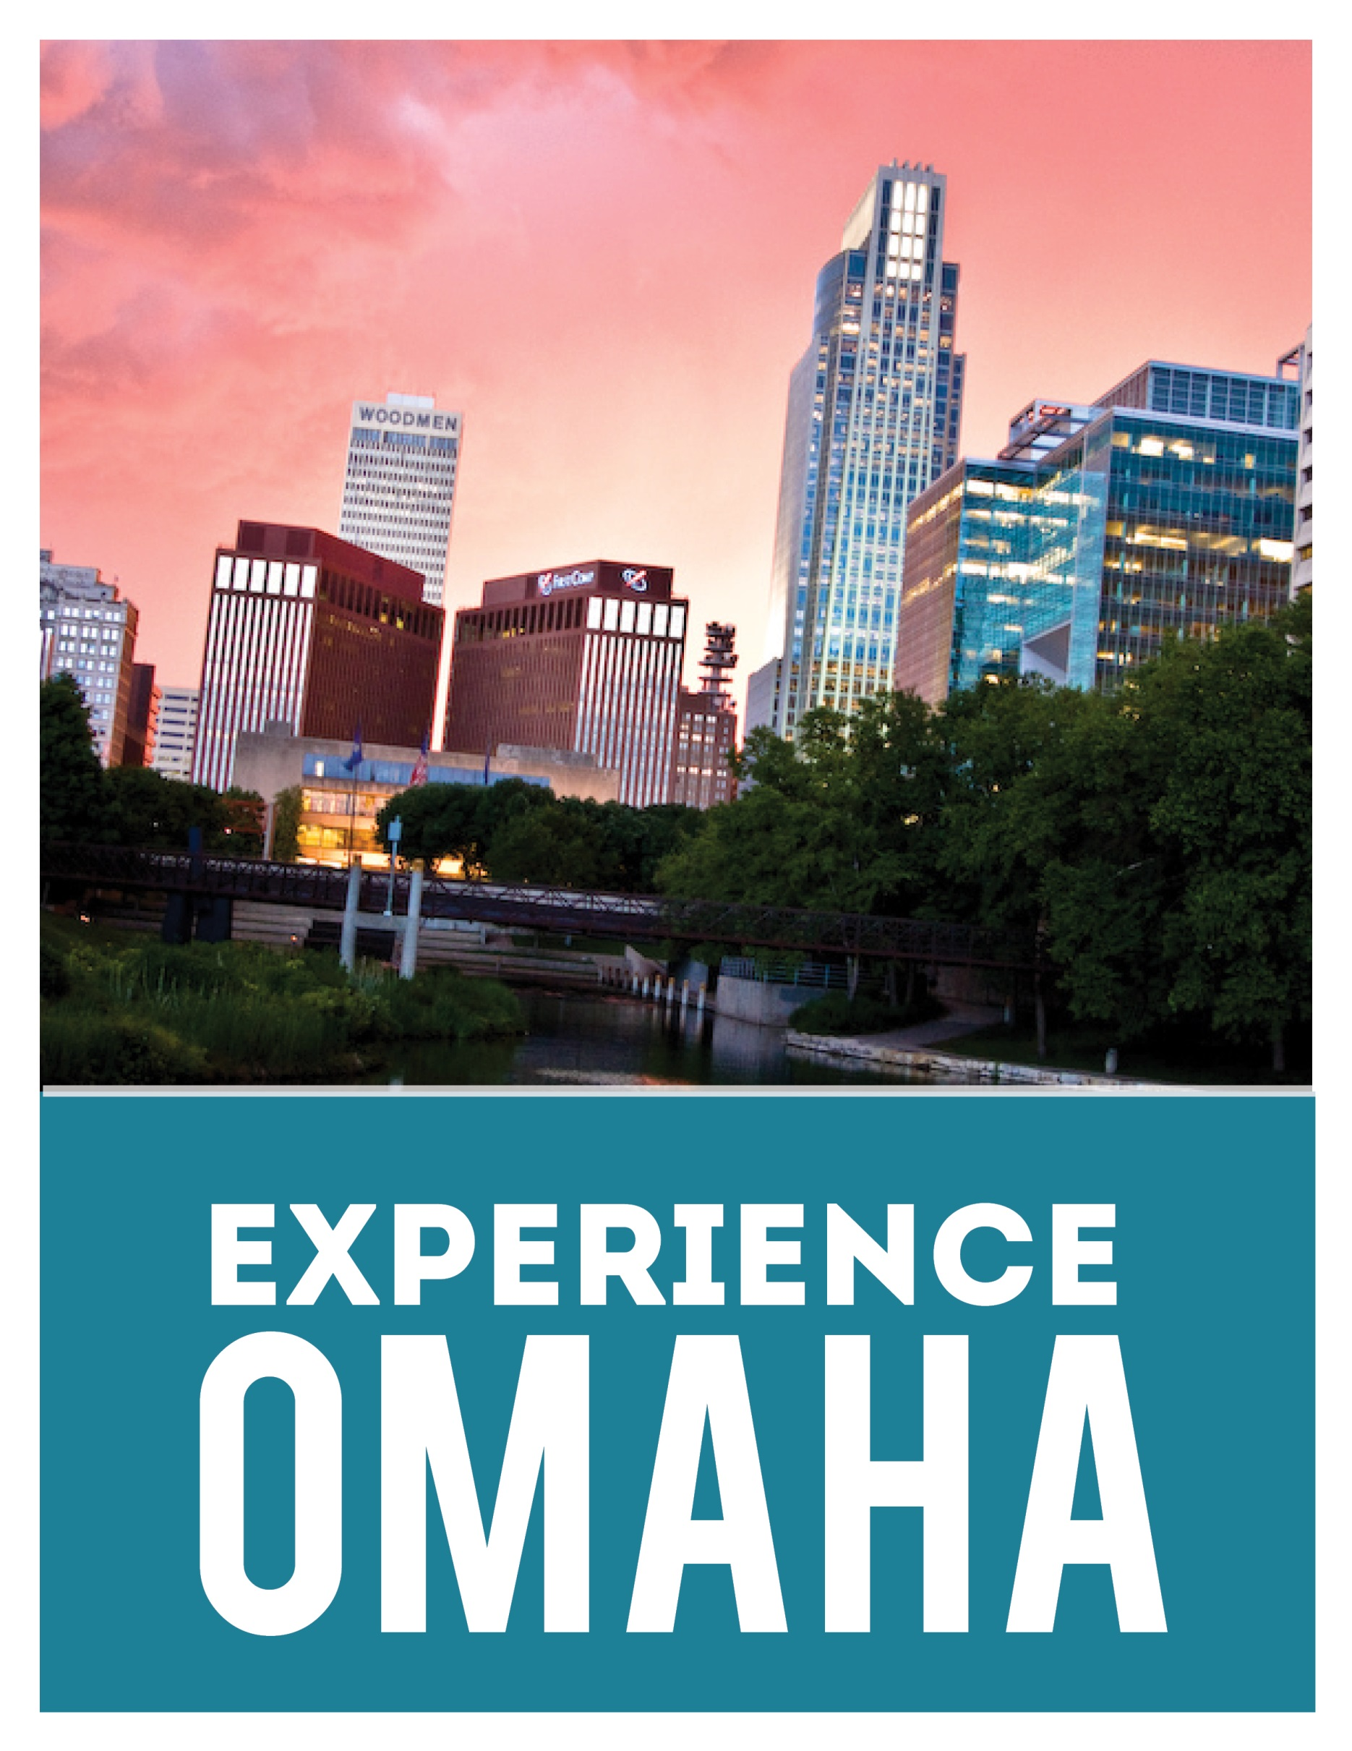

**THE OMAHA MSA…  
 *is on the move with momentum***

The region has benefited from leaders who have vision, determination, and the means to make things happen. It is an area that is economically strong and diverse, and has kept moving, even during challenging economic times.

Some quip that Omaha has become “Echo City.” That’s because when people from elsewhere hear all that’s going on in Omaha, they immediately repeat in surprise, “Omaha?” Yes, Omaha. Named for an American Indian tribe that came west and went upstream, the word is often translated as “the upstream people.” Yes, the up-and-coming metro area is clearly moving ahead.

THE **NUMBERS**

The Omaha metropolitan statistical area (MSA) encompasses **4,400** square miles in eight-counties in two-states.

The MSA has a population of **865,350** of which **416,855** live in the City of Omaha itself.

The adjusted median household income is **$57,901** compared to $53,658 for the U.S. The cost of living is **10-12%** below the national average. In addition the MSA’s average for housing costs is **20%** below the national average.

Percentage of residents with bachelor’s degrees or higher is **32.7** compared to U.S. average of 28.6, with a median age of **34.8** (36 percent of the population is younger than 25). The U.S. median age is 36.9 years.

*Sources: 2011 U.S. Census, American*

*Community Survey, Metropolitan Area*

*Planning Agency, Scarborough Research*

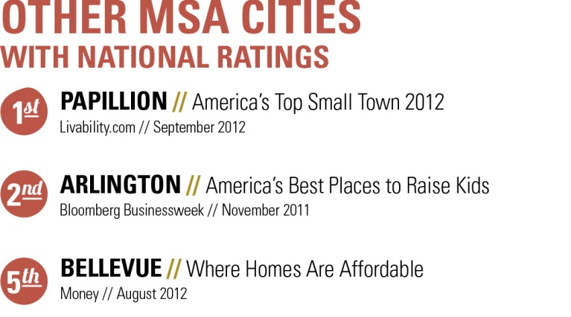

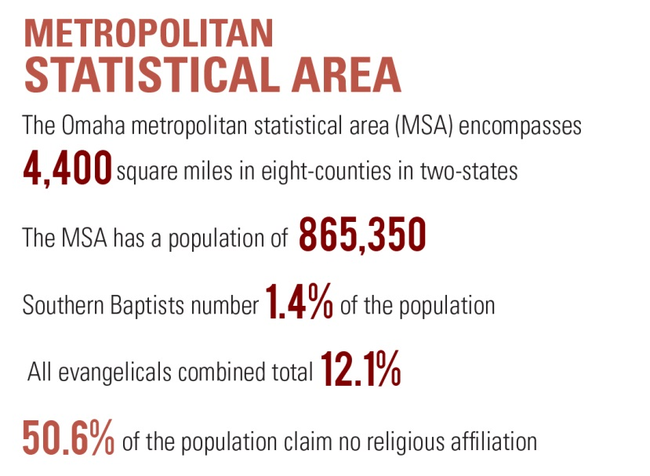

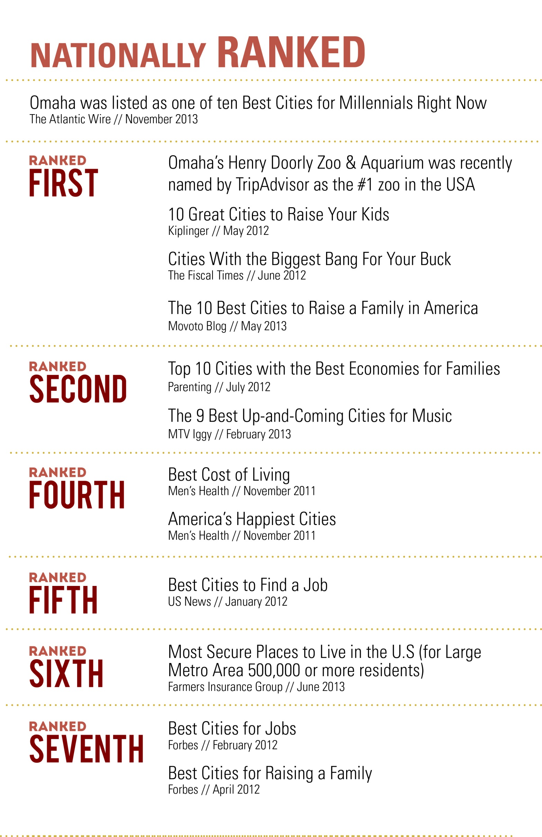

**NEBRASKA: FACT or FICTION**

**FACTS**

• It’s possible to have a high quality of life without a high price tag. Our cost of living is lower than the national average.

• We enjoy a relaxed lifestyle. We have clean air and water, and a crime rate that’s lower than the national average for a metro area of our size (865,350 people in eight counties in two states).

• Our average city commute is 20 minutes by car. We have bus routes and a growing network of bike lanes, and we rarely see a major traffic jam.

• We have a lively and varied arts and entertainment scene, Broadway touring shows and state-of-the-art performance venues.

• We’re strong in the areas of recreation and leisure, too. We have an extensive network of bike trails, challenging golf courses, scenic parks and lakes and busy ball diamonds and soccer fields.

• We have a well-educated community. More than 91 percent of adults ages 25 and older are high school graduates (the national average is 85 percent). Greater Omaha outperforms the national average for college graduates, with about one in three achieving a bachelor’s degree or higher.

• We have easy access to world-class health care facilities and health care costs that are below the national average. Our health care professionals consistently receive national attention for their work.

**FICTION**

• *We have farmland and that’s about it.* Omaha is, among many things, the headquarters of five Fortune 500 companies, two major research medical centers, a world-class performing arts center and one of the top zoos in America. And, of course, home to the Oracle of Omaha, Warren Buffett.

• *We kick up a lot of dust*. “The greatest show on dirt” is not watching a field being plowed. It’s seeing a grounder being fielded in the NCAA Men’s College World Series held annually in Omaha.

• *Everybody wears overalls and plaid shirts.* We’re the fashion capital of the Midwest – or at least we’re building that reputation with Omaha Fashion Week. Since 2008, Fashion Week has given local and regional designers two weeks a year (in the spring and fall) to show case their work. Organizers hope to evolve to the next step by offering designers a chance to produce and sell their collections on a larger scale.

• *There’s nothing to do*. Enjoy art and history museums, a lively performing arts scene, nightlife, a large and diverse offering of restaurants, landmark architecture, college and semi-pro sports, a people-friendly riverfront and a well-developed trails system. There’s so much to do.

• *We’re poor folks*. Thanks partly to Berkshire Hathaway, Omaha has an extensive network of millionaires with a strong history of philanthropy.

• *The population is declining*. Shifting: yes. Declining: no. Only in the 1930s did Nebraska’s population decline. Today, more than half of the state’s population lives in the three largest counties: Douglas and Sarpy (Greater Omaha) and Lancaster (Lincoln). The state’s population is projected to grow 7.3 percent by 2016.

• *Farmers are behind the times*. Today’s farmer operates in a world of GPS guided, high-dollar efficient machinery, and has resources and expertise in biotechnology, animal nutrition, fuel efficiency and commodity markets.



**Economic Diversity Reflected  
in the Area’s Fortune 500 Companies**





**Number 7 • Berkshire Hathaway Inc.**

Known as much for its leader’s personality as it is for a solid, long-term performance for its shareholders, Berkshire Hathaway continues to enjoy a top 10 Position among the world’s companies. The Omaha-based holding company owns businesses in a diverse range of industries, from insurance, railroads, and energy companies, to manufacturers, retailers, fast food and even a chemicals maker.

**Number 143 • Union Pacific**

Tracing its history to Abraham Lincoln’s start of the transcontinental railroad, Union Pacific is celebrating its 150th anniversary as the nation’s premier railroad – and one of America’s iconic companies. While its headquarters are in Omaha, Union Pacific’s operations link 23 states to serve more than 25,000 businesses. Among its largest customers are steamship lines, vehicle manufacturers, agricultural companies, utilities, intermodal companies and chemical manufacturers.

**Number 215 • ConAgra Foods**

From Banquet and Chef Boyardee, to Egg Beaters and Healthy Choice, plus Hunt’s, Manwich, Libby’s and Van Camp’s, to name a few, ConAgra Foods’ consumer brands are found in 97 percent of American households. Its commercial brands make it one of the top suppliers to food service chains and distributors worldwide. ConAgra Foods remains relevant in an industry where it’s imperative to stay up-to-date on changing tastes and preferences.

**Number 255 • Peter Kiewit Sons’, Inc.**

Peter Kiewit Sons’ tagline, “Jobs done well,” may seem like a simplistic principle for this Fortune 500 Company that calls Omaha home. In its more than 125-year history, Kiewit has evolved into one of the largest and most well-respected construction and mining organizations in the world. It is one of the largest employee owned firms in the nation, with both U.S. and Canadian employee shareholders.

**Number 411 • Mutual of Omaha**

With a history that spans from 1909, Mutual of Omaha remains a leading provider of insurance and financial services products for individuals, businesses and groups throughout the United States. Set in the heart of Omaha’s vibrant Midtown Crossing, Mutual continues to make its mark with popular endeavors, including its sponsorship of the U.S. Olympic Trials—Swimming and the iconic TV show, “Mutual of Omaha’s Wild Kingdom.”

**This Diversity is Also Repeated   
in the Areas Fortune 1000 Companies**

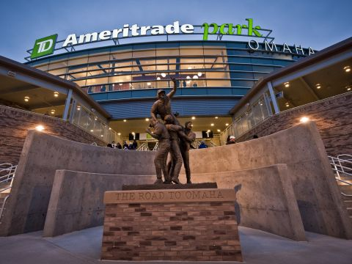

**Green Plains Renewable Energy** (No. 621)

Located in the heart of the nation’s corn country, Green Plains Renewable Energy is well situated to take advantage of the ethanol industry’s growth. This Omaha based company is a vertically integrated ethanol producer, operating nine ethanol plants in Nebraska, Iowa, Michigan, Minnesota, Indiana and Tennessee. In addition to ethanol production, the company operates an agribusiness segment. Its in-house marketing business is responsible for the sale, marketing and distribution of ethanol, as well as the company’s production of distillers’ grains.

**TD Ameritrade** (No. 736)

From pioneering the online brokerage industry to its introduction of touch-tone phone trading and today’s mobile apps, TD Ameritrade is a leader in the development of software, tools and technology that keep pace with the industry. The company is also very people focused, counting millions of investors and independent registered investment advisors among its customers in what the company calls “Bringing Wall Street to Main Street since 1975.”

**Valmont Industries** (No. 762)

A worldwide leader in mechanized irrigation, Valmont Industries continues to spur growth in the industries it serves through the continued expansion of its products. Today, Valmont manufactures pole structures for lighting and utility and access systems and engineered grating products. It also designs, manufactures and installs communication structures, systems and components for wireless communication. Valmont’s operations include 95 facilities in 17 countries and more than 8,000 employees.

**West Corporation** (No. 795)

With employees throughout North America, Europe, the Middle East, Asia Pacific and Latin America, West Corporation continues to be the language of business – regardless of the language spoken. The world’s leading provider of voice-related services, West processes billions of minutes in voice-related transactions every year for clients in communications, consumer industries, financial services, government, health care, insurance, mortgage services, pharmaceuticals, retail, transportation, travel, hospitality and more.

**Werner Enterprises** (No. 924)

A global leader in transportation and logistics, Werner Enterprises’ history is as American as apple pie … and baseball, including Werner Park, home to Omaha’s Triple A baseball club, the Omaha Storm Chasers. Starting with a single truck in 1956, C.L. Werner launched a family business that today includes a diversified portfolio of transportation services. The company provides freight management, truck brokerage, intermodal and international services through domestic and global subsidiaries. Werner recently was named one of Fortune Magazine’s most admired and trusted companies.

=



**Offutt Air Force Base in Bellevue is home of the United States Strategic Command, known as USSTRATCOM. Most civilians hear about the base during its annual air show, but what should we know otherwise? “First of all, the economic impact: It’s not in the thousands or millions of dollars. It’s in the billions of dollars with payroll and ancillary services, contractors and defense industries.**

Offutt’s 2011 Economic Impact Analysis reports its military and civilian payrolls at more than $607 million, with construction, service contracts and other federal expenditures generating another $981 million. When adding indirect jobs valued at $186 million, the total economic impact averages more than $2 billion annually. This past year has seen $35.5 million in new construction, including a new building for the U.S. Navy Reserve, upgrades to the base clinic and a new gate at the south entrance of Offutt.

That work pales in comparison, however, to the new StratCom headquarters, an estimated $524.4 million project that will update and replace the current 55-year-old structure. One of Omaha’s Fortune 500 companies, Kiewit was named general contractor in August 2012, with construction expected to be in full swing by spring 2013. StratCom’s facilities employ 1,700 military personnel and civilians, a number expected to increase once the new facility is operational.

**A Well Respected Medical Community**

**Omaha is one of only 14 US cities with more than one medical school. The two schools have been producing doctors for more than a century. The University of Nebraska Medical School is the older of the two institutions, opening in 1880 as the Nebraska School of Medicine and changing its name a year later to the Omaha Medical College. The school didn't affiliate with the University of Nebraska until 1902. Creighton University established its medical school in 1892.**

Clifton continued, “What we're known for is producing excellent clinicians, as opposed to researchers. They (UNMC) have made federally funded research a much higher priority than we have. That's helped to give them a really distinct niche. For us, we constantly tell our faculty that we always have to remember that we have a different mission. If we're doing what UNMC is doing, then there's no need for us to exist.”

Creighton's campus also will change in the next couple of years: the Creighton University Medical Center no longer will serve as a teaching hospital. That function will shift to Bergan Mercy Medical Center, at 75th Street and Mercy Road. The move will create “a two-campus approach to health-care delivery, to medical education and to research,” said Dr. Don Frey, Creighton's senior vice provost for clinical affairs. To provide students with a clinical setting near campus, he said, a “state-of-the-art” center will be built that will provide space for physicians' offices, research, community outreach and neighborhood meetings. A location has not been selected.

Source: Omaha World Herald insert Outlook 2014: Building on a proud past, looking to a bright future, February 2, 2014

The two academic medical centers focus on different things. Rev. Jim Clifton, an Associate Vice-President, says, “For Creighton, we're not in the health care business, we're in the business of educating health care professionals. The first thing is we want our medical school and our clinical partner to be of the caliber that attracts the best faculty from around the country. We think first of a destination for faculty, as a destination for students and residents and then a destination for patients.”

UNMC Vice-Chancellor for External Affairs Bob Bartee said, we have “a threefold mission: the education piece, the research piece and then the clinical care and outreach piece.” Research is a bigger pursuit among more faculty at UNMC, the state school, than it is at Creighton, the private, Catholic school: UNMC investigators were awarded $94.3 million in research grants in 2012-13, while Creighton researchers received $19.3 million. Clifton is proud of the research that's done at Creighton, but notes it's not the school's main focus.

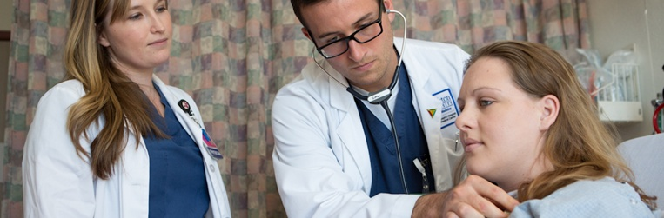

**In addition to the two medical schools the area boasts a significant network of hospitals and clinics. Two that are somewhat unique are Children’s Hospital and Boys Town National Research Hospital.**

Children's Hospital and Medical Center has a rich history based on community involvement and service to children. The original Children's Memorial Hospital was founded in 1948 by Dr. C.W.M. Poynter, dean of the University of Nebraska Medical Center, and Henry Doorly, publisher of the *Omaha World-Herald*, with a vision that no child in need of medical care would be turned away due to an inability to pay. Today, families from across a five-state region and beyond seek the experience and expertise of Children's Hospital and Medical Center.  They provide care to more than 250,000 children each year.

Since the opening of Boys Town National Research Hospital in 1977, the hospital has been internationally recognized as a leader in clinical and research programs focusing on childhood deafness, visual impairment and related communication disorders. They have developed national medical programs that are now instituted in hospitals and clinics across the country.

Today, the hospital offers a broad range of clinical services, including ear, nose and throat services at the Boys Town Ear, Nose and Throat Institute, general pediatric care with Boys Town Pediatrics, and orthopaedic, internal medicine, pediatric gastroenterology, allergy, asthma, pediatric pulmonology, behavioral health, audiological and ophthalmologic care.

The hospital has expanded to offer surgical and clinical services at two Omaha locations: 555 North 30th Street in Omaha and 14000 Hospital Road on the campus of Boys Town, Nebraska.

Boys Town National Research Hospital has assembled national leaders in research who are making important contributions in the areas of genetics, hearing, language, vision and speech disorders. Applying these findings with new technologies, distance learning and the exploration of new research frontiers, the opportunities for new medical diagnoses, evaluation and treatment discoveries are endless.

Accredited by The Joint Commission, Boys Town National Research Hospital is dedicated to providing leading edge clinical care, pioneering translational research and improving the lives of children and their families through applied technology and educational outreach programs. The hospital annually serves more than 40,000 children and families from across the United States.



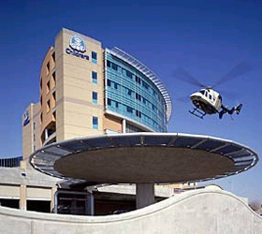

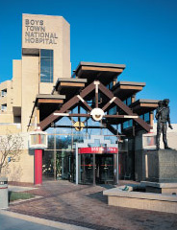

**Excellence in Children’s Care**

The Arts, Entertainment, and Sports

Until the last 15 years, “Omaha had a very small group of entertainment choices,” said Paul Hendrickson, general manager of the newest venue, the Ralston Arena. “They have since then exponentially increased way beyond the normal nationwide.” National touring acts and major sports events — along with the ticket-buying public — have taken note of the Omaha area's plentiful lineup of attractive, popular venues of varying capacities, said Hendrickson and two other managers of Omaha-area entertainment organizations.

Consider this: The venerable 2,600-seat Orpheum, built in 1927 and renovated in 1975 and 2002, ranked 59th among all indoor U.S. and Canadian venues — including the largest domed stadiums — in gross ticket income from October 2012 to October 2013, according to the December 2013 issue of *Venues Today magazine*.

The Orpheum sold $11.5 million in tickets for 106 shows during the period, ranking it 13th among venues of 2,001 to 5,000 seats, the magazine reported. Meanwhile, the eight-year-old, 2,000-seat Holland Performing Arts Center ranked 10th among venues of 2,000 or fewer seats, taking in $3.1 million in tickets sold for 85 shows.

The risk for Omaha's entertainment industry, the managers say, has shifted to overbuilding in light of the October 2012 opening of the Ralston Arena, a shortage of arena business at Council Bluffs' 12-year-old Mid-America Center and a projected on-campus sports arena for the University of Nebraska at Omaha.

The way Omaha has embraced the NCAA College World Series for more than 60 years laid a foundation that has helped the city host two U.S. Olympic Swimming Trials — and a third is scheduled for 2016.

CenturyLink Center Omaha also has been the site of the 2013 U.S. Figure Skating national championships, NCAA basketball and volleyball events, and two major equestrian events.

More are on the way, including three events in 2015 — the FIVB World Grand Prix volleyball finals, second- and third-round NCAA basketball games and the NCAA volleyball final four, which the city hosted in 2006 and 2008.

Omaha also is one of the finalists — along with London, Hong Kong and a Dutch city call ‘s-Hertogenbosch — to host another equestrian event, the Federation Equestre Internationale’s 2017 World Cup Finals.

The CenturyLink Center is an incredible venue for sporting events. With the convention center attached on the same footprint, athletes and coaches in all sports love the accessibility. No transportation is needed for practice. The hotel is right next door, and you don’t have to go outside. Basketball teams can pull their buses inside and not have to deal with the elements when coming into or leaving the building.

For the swim trials, a warm-up pool was set up in the convention center, 100 feet from the pool. A practice/ warm-up rink was installed for the figure skating championships in that same area. For the bigger volleyball tournaments, extra courts are set up in the convention center.

In sporting venues in many cities athletes have to travel across town to find practice facilities. The proximity of Omaha’s airport to the downtown area has been another aspect that receives nothing but positive feedback. In Omaha the airport is only five minutes, and so many of the hotels have shuttle service to and from the airports. They even will take people to attractions within a certain radius.

**The Arts, Entertainment & Sports**

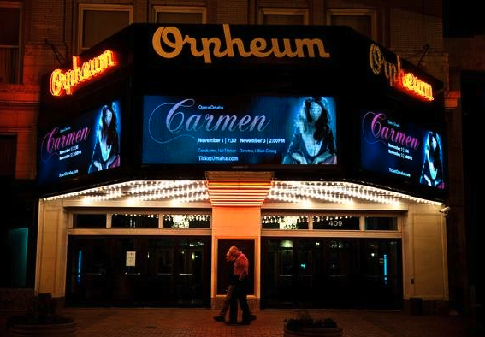

Though CenturyLink Center Omaha didn't make the *Venues Today* list, the 11-year-old facility — still the largest among the area's modern performing venues — has attracted an impressive array of performers that includes U2, Bruce Springsteen, Paul McCartney, Carrie Underwood and Taylor Swift.

**HIGHER**

**EDUCATION**

**College of St. Mary** is an all-women liberal arts Catholic university. They offer numerous undergraduate and graduate degrees in health care, business, education, liberal arts, and sciences.

**Grace University** is a regionally accredited, private Christian university with more than 40 undergraduate, graduate, and adult degree completion programs including education, business, psychology, music, nursing, pre-law, ad Christian ministries. The school’s mission is to develop servant leaders for the home, the church, and the world through excellence in biblically integrated education.

Children who learn in Omaha go on to great things, which is one reason *Business Facilities* listed us as having one of the Top 25 “Best Educated Workforces.” Test scores among students in the Omaha Public Schools exceed the national average for large school districts. Sixty-one percent of graduates going on to college or other post-secondary schools, with the help of $25 million in scholarship offers each year. Metro public school districts educate 88 percent of the area’s children, while outstanding private, parochial and non denominational schools educate the rest.

In the area of higher education, Omaha’s Creighton University and the University of Nebraska at Omaha both have legitimate claims to crown-jewel status in the area. This is bolstered by the universities’ significant facelifts over the past 20 years, nationally and internationally recognized academic programs and athletic departments that recently have leapt into higher levels of competition.

Both institutions have set ambitious enrollment goals over the next decade that would push Creighton’s total enrollment toward 10,000 and UNO’s to 20,000. Creighton leaders hope to parlay the university’s new Big East Conference membership into greater enrollment from Chicago and the East Coast, even as they expand their online academic footprint and build a nationwide network of partner schools.

UNO, for its part, plans to build a set of new athletic fields and an indoor arena to complement its still-new NCAA Division I status. University leaders also intend to keep adding residence halls, expanding fine-arts and telecommunications facilities, and improving the high-technology resources and academic programs that helped spark UNO’s transformation from a relatively limited “commuter campus” within the University of Nebraska college system. In addition to these two Division I schools, the area has the following major institutions:

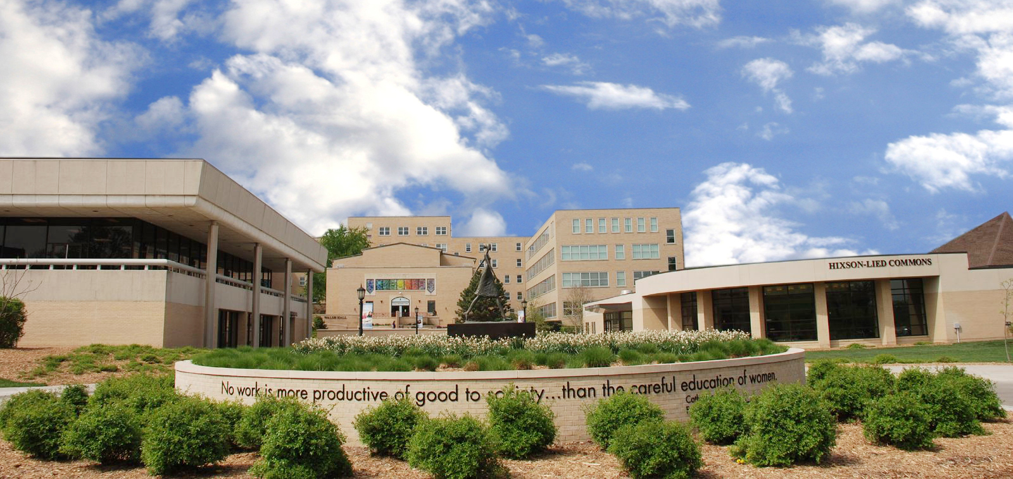

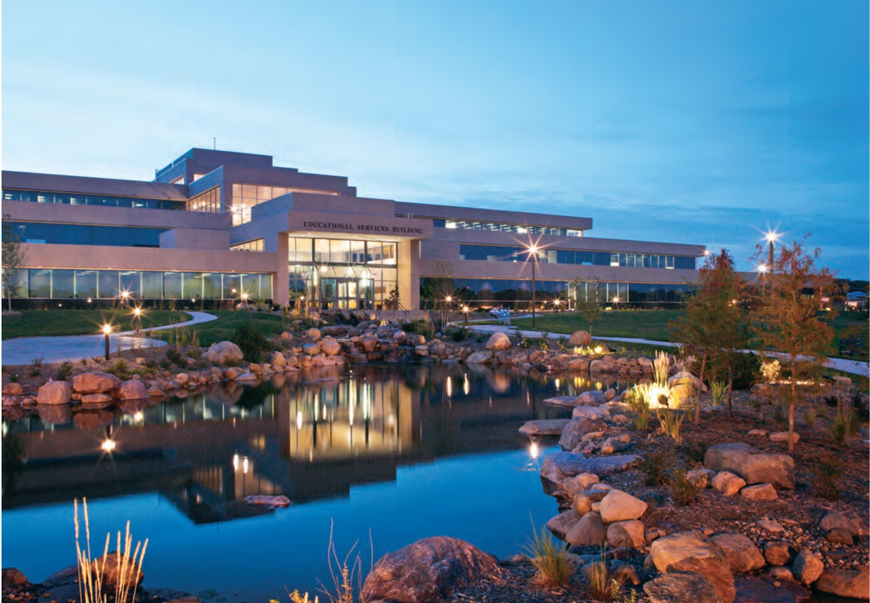

**Bellevue University** is a private, nonprofit university of business, professional education, and the liberal arts. It offers 50 bachelor degree programs and 20 master’s degree programs in class and online. It also offers the nation’s only Ph.D. in Human Capital Management.

**Midland University** is a four-year liberal arts and sciences college offering nearly 50 majors and pre-professional programs. The Fremont campus offers a 10 to 1 student to faculty ratio ad offers a four-year graduation guarantee. Midland aims at establishing a tight-knit, active campus community with curriculum dedicated to hands-on, interactive learning. In the last four years, Midland has added 11 varsity sports, has worked to enhance clubs and activities, ad has increased opportunities in the performing arts nearly tenfold.

**Nebraska Christian College** specializes in creating church leaders. The Papillion campus offers a well-rounded education in the classroom, classes involving how to read and interpret the Bible, and practical ministry philosophy. The Institute for Church Leadership launched in 2013 offers both a community resource for regional church leaders and an honors college environment. The institute gives students fact time with ministry practitioners from across the nation, helps them develop a professional network, and allows them to continue to grow in their skills after graduation.

**Nebraska Methodist College**, which was established in 1891, is a private health professional and nursing college. An affiliate of the Methodist Health System, the college offers certificate, undergraduate, and graduate degrees with programs offered on campus and online. It recently announced its first doctoral program, the Doctor of Nursing Practice, which will begin in the fall of 2014.

**Clarkson College** prepares students for a career in health care services. They offer students a variety of diplomas and certificates, as well as undergraduate, graduate, and post-graduate degrees in the fields of nursing and health care. In he past three years the college has introduced three new programs: Doctorate of Nursing Practice, Doctorate in Health Care Education and Leadership, and the Long-term Care Certificate program. In 2013 the college celebrated its 125th Anniversary ad received notice from U.S. news and World Report in the categories of Best Online Graduate Nursing Program and Best Online Graduate Nursing Program for Veterans.

**Iowa Western Community College** in Council Bluffs offers more than 100 academic programs, including a variety of practical, hands-on experiences and programs that last one to two years. The school is continuing to expand its campus with the building of an 85,000 square-foot, two-story facility which will house the Adult Basic Education, CNC Machining, Electronics, Environmental, GED, Industrial Maintenance, Math, Robotics, Sustainability, and Welding programs.

**The Metropolitan Community College** of Omaha has eight locations in the metro area. It is a comprehensive, public community college that strives to offer affordable and quality education to all residents in Dodge, Douglas, Sarpy, and Washington Counties. It has the largest enrollment of the six community colleges in Nebraska and is the second-largest postsecondary institution in the state serving more than 40,000 students annually. Metro is continually expanding its flexible course formats to meet student demand. The college offers multiple online degree programs, hundreds of online classes, and a growing list of hybrid course options that blend online and on-campus learning.

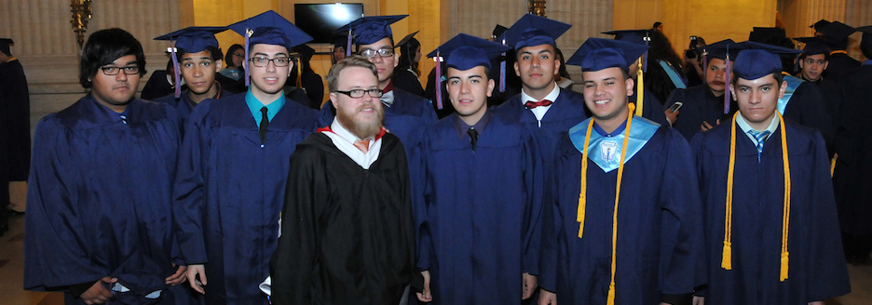

**Must Sees in the Area**



**THE DURHAM MUSEUM**

801 S. 10th St. • Its beautiful architecture blends with memories of a time gone by at this exquisitely restored Art Deco train station near Omaha’s Old Market. More than a railroad museum, The Durham celebrates the history of the region and offers a broad range of traveling exhibits through the museum’s affiliation with the Smithsonian Institution and strong ties with the Library of Congress, National Archives and the Field Museum. There’s a lot to see — from interactive bronze figures in the Great Hall, to a 1940s streetcar and1890s train cars. Enjoy a phosphate from the soda fountain, and souvenir shopping at the museum gift shop. The museum’s signature event, Christmas at Union Station, is a community favorite for live entertainment around a large, decorated tree in the Great Hall.

**THE OLD MARKET**

**B**ounded on the east and west by 10th and 14th Streets, and on the north and south by Farnam and Leavenworth Streets. • The area is always bustling. It pulls visitors and locals to its top-notch restaurants, retail shops and art galleries. Brick-paved streets, horse-drawn carriages and street musicians add flavor to this hangout district. Shops sell the offbeat and unusual, from handmade silver jewelry and soft leather garments to quirky greeting cards and Christmas ornaments. Vendors of produce, flowers and things garden-grown gave the Old Market its name and reputation. On Saturdays from late spring to early fall, the Omaha Farmers Market is a nod to that tradition. Vendors come from rural Nebraska and Iowa to display their wares in tents, under awnings and on the streets.

It’s all about the food for many Old Market faithfuls. Aromas waft into the streets from exotic and traditional fare prepared inside some of the city’s A-list establishments.

**HENRY DOORLY ZOO & AQUARIUM**

3701 S. 10th St. • Recently named by online travel site TripAdvisor as the No. 1 zoo in the United States, Omaha’s Henry Doorly Zoo & Aquarium already had fans convinced of that. With its Lied Jungle and Desert Dome singled out for special mention, the zoo also offers visitors an unusually large number of animals within 200 yards of the entrance gates. For decades now, visitors have come to the zoo to vicariously travel the world. Tropical rainforests grow inside the Lied Jungle. Desert canyons dominate the Desert Dome. Other-worldly creatures inhabit the Kingdoms of the Night. Endangered animals make the scene at Expedition Madagascar. In the redesigned and renovated Suzanne and Walter Scott Aquarium, sharks and rays glide over and around zoo visitors watching from an underwater tunnel.

**Love’s Jazz & Arts Center**

2510 N. 24th St. • Born of a revitalization effort in North Omaha, Love’s Jazz and Arts Center is the only facility in the region dedicated to preserving, presenting and promoting African American art and jazz. The center explores the contributions of those who’ve impacted the world of jazz, including Omaha’s own legendary jazz musician Preston Love Sr.

**El Museo Latino**

4701 S. 25th St. • It is one of only eleven Latino art and history museums in the United States today. Located in the heart of South Omaha, El Museo Latino invites the community to explore its latest exhibits, participate in art, music or folklorico dance classes, and join in special celebrations of Cinco de Mayo and Hispanic Heritage Month.

**JOSLYN ART MUSEUM**

2200 Dodge St. • Sarah Joslyn’s gift to the people of Omaha in memory of her husband, George, is the crown jewel among the city’s many cultural treasures. The museum, built in 1931 with pink marble imported from Europe, is one of the finest examples of Art Deco architecture in the nation. The Walter and Suzanne Scott Pavilion, added in 1994, was designed by renowned British architect Norman Foster. Past and present meet under a massive Chihuly sculpture with more than 2,000 pieces of individually blown glass. The museum is known for its eclectic collection of works, beginning with Greek pottery and moving through Europe and into American Western art and finishing in the 20th century. The museum’s outdoor sculpture garden features more than 20 works for public enjoyment

**LAURITZEN GARDENS,   
OMAHA’S BOTANICAL CENTER**

100 Bancroft St. • On any given day, any of 20 themed gardens at this 100-acre botanical center could be your favorite. Let’s say you have your children or grandchildren in tow. Take them to the Sunflower Forest, then head for the model railroad garden with its bridges, tunnels and city landmark buildings made of natural materials. You can walk the trails or take the tram (May through September). If the weather is less-than-ideal, the visitors’ center is an oasis from the elements. October through May, you will see major floral displays from the onsite greenhouses. Kenefick Park, visible from westbound Interstate 80, shares its parking lot with the botanical center. The park is a must-see for train buffs. Two pristine historic locomotives from Union Pacific Railroad make their home here.

**STRATEGIC AIR & SPACE MUSEUM**

I-80 Exit 426, near Ashland, Neb. • The Strategic Air & Space Museum is dedicated to the preservation of historic aircraft and artifacts from the Strategic Air Command. There are educational adventures for kids and traveling exhibits for all ages. The main entrance features a jaw-dropping Lockheed SR- 71A Blackbird spy plane. The most recent and significant addition is an old war horse that required six years to be restored to its original glory. In September 2012, the museum unveiled one of the world’s last surviving Boeing B-29 Super fortresses, “Lucky Lady.”

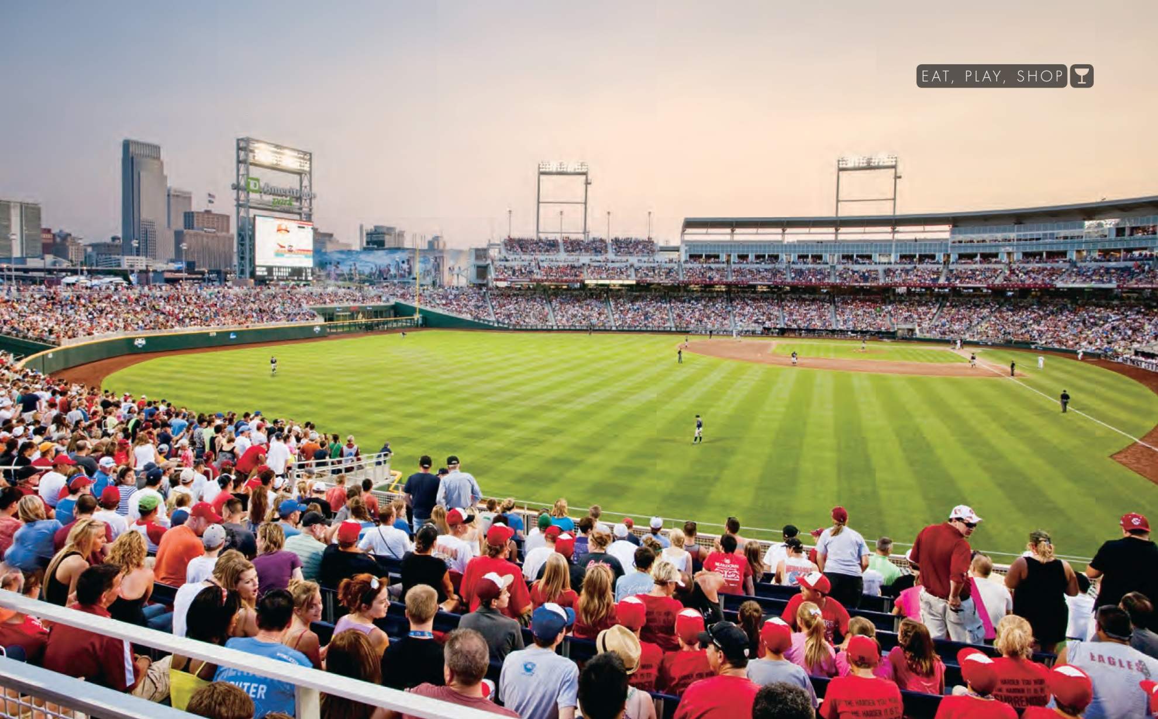

Southern Baptists who first came to the area in the late 1950s represent 1.4% of the population and all Evangelicals combined are 12.1% (this includes some groups that traditional SBC folks would not feel comfortable being included as evangelical). The data on the following pages provides a more in depth picture of the religious climate in the area.

This increasing diversity and the challenges they represent create a number of opportunities for Southern Baptists in the area of evangelism and church starting. They include…

* Exploding ethnic minorities (Omaha has the largest Sudanese population in America).
* Connecting with the various inner city opportunities among African-Americans (the Eastern Nebraska Baptist Association includes 10 predominantly African American Churches)
* Reaching college students (there are over 70,000 students in the MSA)
* Ministering to the least among us (Set Free Church is helping to lead the charge in this area).
* Expanding suburban areas—in the last decade hundreds of acres of farmland have been converted to housing developments.
* Growing bedroom communities—the MSA includes dozens of smaller communities that are experiencing significant and at times uncomfortable population growth.
* Declining population areas in rural counties and small towns where low income families are able to find inexpensive housing—most of these areas have no SBC church and very few evangelical churches of any kind.
* Struggling small churches, some of which are open to a revitalization strategy.

If your church is looking for an opportunity to impact lostness for the glory of God, contact us. The partnership opportunities are significant and varied. Call Mark Elliott or John Mark Hansen at 402-551-0608 or e-mail us at [enba@enbasbc.org](mailto:enba@enbasbc.org).

**Historically Roman Catholic and Lutheran with a heavy dose of United Methodist, the area’s fiscally conservative, but religiously moderate culture is experiencing significant change. For example, in 1997, Jimmy Creech, then Senior Pastor of The First United Methodist Church of Omaha, officiated at the wedding of a lesbian couple. The area has added to the historic Moorman Temple a number of Muslim Mosques as well as houses of worship for Buddhist, Hindu, Sikh, Tao, and Zoarastrians. The area boasts the construction of the Tri-Faith Center in 2012 that includes a Jewish Temple, Islamic Center, and an Episcopalian Church.**

**The Religious Climate is Shifting!**



**Omaha MSA Religious Data**

Congregational believers include all full members, their children, and others who regularly attend services. The 2010 reports contain incomplete counts of places of worship and believers belonging to the eight largest historically African-American denominations. These denominations are not included in the 2000 reports and are largely missing from the 1990 and 1980 reports.

|  |  |  |  |  |  |
| --- | --- | --- | --- | --- | --- |
| **Religious Bodies** | [**Tradition**](http://www.thearda.com/rcms2010/r/m/36540/rcms2010_36540_metro_tradition_2010.asp) | [**Family**](http://www.thearda.com/rcms2010/r/m/36540/rcms2010_36540_metro_family_2010.asp) | **Places of Worship** | [**Believers**](http://www.thearda.com/rcms2010/r/m/36540/rcms2010_36540_metro_adh_2010.asp) | **Rate\*** |
| [African Methodist Episcopal Church](http://www.thearda.com/Denoms/D_937.asp) | [Black Protestant](http://www.thearda.com/rcms2010/blackprot.asp) | [Methodist/Pietist](http://www.thearda.com/Denoms/families/F_92.asp) | 4 | 693 | 0.8 |
| [African Methodist Episcopal Zion Church](http://www.thearda.com/Denoms/D_1322.asp) | [Black Protestant](http://www.thearda.com/rcms2010/blackprot.asp) | [Methodist/Pietist](http://www.thearda.com/Denoms/families/F_92.asp) | 2 | 252 | 0.3 |
| [American Baptist Churches in the USA](http://www.thearda.com/Denoms/D_1454.asp) | [Mainline Protestant](http://www.thearda.com/rcms2010/mainline.asp) | [Baptist](http://www.thearda.com/Denoms/families/F_96.asp) | 21 | 3,589 | 4.1 |
| [Anglican Church in North America](http://www.thearda.com/Denoms/D_1284.asp) | [Evangelical Protestant](http://www.thearda.com/rcms2010/evangelical.asp) | [Episcopalianism/Anglicanism](http://www.thearda.com/Denoms/families/F_88.asp) | 1 | --- | --- |
| [Antiochian Orthodox Christian Archdiocese of North America, The](http://www.thearda.com/Denoms/D_1229.asp) | [Orthodox](http://www.thearda.com/rcms2010/orthodox.asp) | [Eastern Liturgical (Orthodox)](http://www.thearda.com/Denoms/families/F_89.asp) | 2 | 385 | 0.4 |
| [Assemblies of God](http://www.thearda.com/Denoms/D_1021.asp) | [Evangelical Protestant](http://www.thearda.com/rcms2010/evangelical.asp) | [Pentecostal](http://www.thearda.com/Denoms/families/F_94.asp) | 22 | 6,767 | 7.8 |
| [Association of Free Lutheran Congregations](http://www.thearda.com/Denoms/D_1302.asp) | [Evangelical Protestant](http://www.thearda.com/rcms2010/evangelical.asp) | [Lutheran](http://www.thearda.com/Denoms/families/F_90.asp) | 1 | --- | --- |
| Association of Reformed Baptist Churches of America | [Evangelical Protestant](http://www.thearda.com/rcms2010/evangelical.asp) | [Baptist](http://www.thearda.com/Denoms/families/F_96.asp) | 1 | --- | --- |
| [Bahá'í](http://www.thearda.com/Denoms/D_1135.asp) | [Other](http://www.thearda.com/rcms2010/other.asp) | [Other Groups](http://www.thearda.com/Denoms/families/F_113.asp) | 2 | 236 | 0.3 |
| Buddhism, Mahayana | [Other](http://www.thearda.com/rcms2010/other.asp) | [Other Groups](http://www.thearda.com/Denoms/families/F_113.asp) | 5 | 3,392 | 3.9 |
| Buddhism, Theravada | [Other](http://www.thearda.com/rcms2010/other.asp) | [Other Groups](http://www.thearda.com/Denoms/families/F_113.asp) | 1 | 15 | 0.0 |
| Calvary Chapel Fellowship Churches | [Evangelical Protestant](http://www.thearda.com/rcms2010/evangelical.asp) | [Pentecostal](http://www.thearda.com/Denoms/families/F_94.asp) | 2 | --- | --- |
| [Catholic Church](http://www.thearda.com/Denoms/D_836.asp) | [Catholic](http://www.thearda.com/rcms2010/catholic.asp) | [Catholicism](http://www.thearda.com/Denoms/families/F_87.asp) | 93 | 187,076 | 216.2 |
| [Christian and Missionary Alliance, The](http://www.thearda.com/Denoms/D_966.asp) | [Evangelical Protestant](http://www.thearda.com/rcms2010/evangelical.asp) | [Holiness](http://www.thearda.com/Denoms/families/F_93.asp) | 13 | 11,622 | 13.4 |
| [Christian Brethren](http://www.thearda.com/Denoms/D_1100.asp) | [Evangelical Protestant](http://www.thearda.com/rcms2010/evangelical.asp) | [Ind. Fundamentalist](http://www.thearda.com/Denoms/families/F_97.asp) | 1 | --- | --- |
| [Christian Church (Disciples of Christ)](http://www.thearda.com/Denoms/D_1071.asp) | [Mainline Protestant](http://www.thearda.com/rcms2010/mainline.asp) | [Baptist](http://www.thearda.com/Denoms/families/F_96.asp) | 14 | 2,729 | 3.2 |
| [Christian Churches and Churches of Christ](http://www.thearda.com/Denoms/D_1070.asp) | [Evangelical Protestant](http://www.thearda.com/rcms2010/evangelical.asp) | [Baptist](http://www.thearda.com/Denoms/families/F_96.asp) | 23 | 8,465 | 9.8 |
| [Christian Methodist Episcopal Church](http://www.thearda.com/Denoms/D_1424.asp) | [Black Protestant](http://www.thearda.com/rcms2010/blackprot.asp) | [Methodist/Pietist](http://www.thearda.com/Denoms/families/F_92.asp) | 1 | 126 | 0.1 |
| [Christian Reformed Church in North America](http://www.thearda.com/Denoms/D_921.asp) | [Evangelical Protestant](http://www.thearda.com/rcms2010/evangelical.asp) | [Presbyterian-Reformed](http://www.thearda.com/Denoms/families/F_91.asp) | 1 | 166 | 0.2 |
| [Church of Christ (Holiness), U.S.A.](http://www.thearda.com/Denoms/D_987.asp) | [Evangelical Protestant](http://www.thearda.com/rcms2010/evangelical.asp) | [Holiness](http://www.thearda.com/Denoms/families/F_93.asp) | 1 | --- | --- |
| [Church of Christ, Scientist](http://www.thearda.com/Denoms/D_1126.asp) | [Other](http://www.thearda.com/rcms2010/other.asp) | [Christian Science](http://www.thearda.com/Denoms/families/F_102.asp) | 3 | --- | --- |
| [Church of God (Anderson, Indiana)](http://www.thearda.com/Denoms/D_1349.asp) | [Evangelical Protestant](http://www.thearda.com/rcms2010/evangelical.asp) | [Holiness](http://www.thearda.com/Denoms/families/F_93.asp) | 1 | 65 | 0.1 |
| [Church of God (Cleveland, Tennessee)](http://www.thearda.com/Denoms/D_1347.asp) | [Evangelical Protestant](http://www.thearda.com/rcms2010/evangelical.asp) | [Pentecostal](http://www.thearda.com/Denoms/families/F_94.asp) | 6 | 1,173 | 1.4 |
| [Church of God General Conference](http://www.thearda.com/Denoms/D_1458.asp) | [Evangelical Protestant](http://www.thearda.com/rcms2010/evangelical.asp) | [Adventist](http://www.thearda.com/Denoms/families/F_98.asp) | 1 | 113 | 0.1 |
| [Church of God in Christ](http://www.thearda.com/Denoms/D_988.asp) | [Black Protestant](http://www.thearda.com/rcms2010/blackprot.asp) | [Pentecostal](http://www.thearda.com/Denoms/families/F_94.asp) | 15 | 2,237 | 2.6 |
| [Church of God of Prophecy](http://www.thearda.com/Denoms/D_1359.asp) | [Evangelical Protestant](http://www.thearda.com/rcms2010/evangelical.asp) | [Pentecostal](http://www.thearda.com/Denoms/families/F_94.asp) | 1 | 143 | 0.2 |
| [Church of Jesus Christ of Latter-day Saints, The](http://www.thearda.com/Denoms/D_1117.asp) | [Other](http://www.thearda.com/rcms2010/other.asp) | [Latter-day Saints](http://www.thearda.com/Denoms/families/F_100.asp) | 32 | 13,404 | 15.5 |
| [Church of the Brethren](http://www.thearda.com/Denoms/D_1180.asp) | [Evangelical Protestant](http://www.thearda.com/rcms2010/evangelical.asp) | [European Free-Church](http://www.thearda.com/Denoms/families/F_95.asp) | 1 | 81 | 0.1 |
| [Church of the Nazarene](http://www.thearda.com/Denoms/D_1441.asp) | [Evangelical Protestant](http://www.thearda.com/rcms2010/evangelical.asp) | [Holiness](http://www.thearda.com/Denoms/families/F_93.asp) | 9 | 1,365 | 1.6 |
| [Churches of Christ](http://www.thearda.com/Denoms/D_1093.asp) | [Evangelical Protestant](http://www.thearda.com/rcms2010/evangelical.asp) | [Baptist](http://www.thearda.com/Denoms/families/F_96.asp) | 10 | 1,716 | 2.0 |
| [Community of Christ](http://www.thearda.com/Denoms/D_1179.asp) | [Other](http://www.thearda.com/rcms2010/other.asp) | [Latter-day Saints](http://www.thearda.com/Denoms/families/F_100.asp) | 10 | 1,890 | 2.2 |
| [Conservative Baptist Association of America](http://www.thearda.com/Denoms/D_1382.asp) | [Evangelical Protestant](http://www.thearda.com/rcms2010/evangelical.asp) | [Baptist](http://www.thearda.com/Denoms/families/F_96.asp) | 2 | --- | --- |
| [Conservative Congregational Christian Conference](http://www.thearda.com/Denoms/D_1311.asp) | [Evangelical Protestant](http://www.thearda.com/rcms2010/evangelical.asp) | [Presbyterian-Reformed](http://www.thearda.com/Denoms/families/F_91.asp) | 1 | 308 | 0.4 |
| Conservative Judaism | [Other](http://www.thearda.com/rcms2010/other.asp) | [Judaism](http://www.thearda.com/Denoms/families/F_106.asp) | 1 | 1,380 | 1.6 |
| Conservative Yearly Meetings of Friends* | [Evangelical Protestant](http://www.thearda.com/rcms2010/evangelical.asp) | [European Free-Church](http://www.thearda.com/Denoms/families/F_95.asp) | 1 | 15 | 0.0 |
| [Converge Worldwide/Baptist General Conference](http://www.thearda.com/Denoms/D_1066.asp) | [Evangelical Protestant](http://www.thearda.com/rcms2010/evangelical.asp) | [Baptist](http://www.thearda.com/Denoms/families/F_96.asp) | 10 | 1,290 | 1.5 |
| [Coptic Orthodox Church](http://www.thearda.com/Denoms/D_861.asp) | [Orthodox](http://www.thearda.com/rcms2010/orthodox.asp) | [Eastern Liturgical (Orthodox)](http://www.thearda.com/Denoms/families/F_89.asp) | 1 | 80 | 0.1 |
| [Episcopal Church](http://www.thearda.com/Denoms/D_849.asp) | [Mainline Protestant](http://www.thearda.com/rcms2010/mainline.asp) | [Episcopalianism/Anglicanism](http://www.thearda.com/Denoms/families/F_88.asp) | 12 | 3,589 | 4.1 |
| [Evangelical Covenant Church, The](http://www.thearda.com/Denoms/D_1368.asp) | [Evangelical Protestant](http://www.thearda.com/rcms2010/evangelical.asp) | [Methodist/Pietist](http://www.thearda.com/Denoms/families/F_92.asp) | 8 | 1,301 | 1.5 |
| [Evangelical Free Church of America, The](http://www.thearda.com/Denoms/D_1438.asp) | [Evangelical Protestant](http://www.thearda.com/rcms2010/evangelical.asp) | [Methodist/Pietist](http://www.thearda.com/Denoms/families/F_92.asp) | 8 | 1,765 | 2.0 |
| [Evangelical Lutheran Church in America](http://www.thearda.com/Denoms/D_1415.asp) | [Mainline Protestant](http://www.thearda.com/rcms2010/mainline.asp) | [Lutheran](http://www.thearda.com/Denoms/families/F_90.asp) | 56 | 35,602 | 41.1 |
| [Evangelical Presbyterian Church](http://www.thearda.com/Denoms/D_1483.asp) | [Evangelical Protestant](http://www.thearda.com/rcms2010/evangelical.asp) | [Presbyterian-Reformed](http://www.thearda.com/Denoms/families/F_91.asp) | 1 | 1,071 | 1.2 |
| [Fellowship of Evangelical Bible Churches](http://www.thearda.com/Denoms/D_1330.asp) | [Evangelical Protestant](http://www.thearda.com/rcms2010/evangelical.asp) | [European Free-Church](http://www.thearda.com/Denoms/families/F_95.asp) | 2 | 525 | 0.6 |
| [Foursquare Gospel, International Church of](http://www.thearda.com/Denoms/D_1006.asp) | [Evangelical Protestant](http://www.thearda.com/rcms2010/evangelical.asp) | [Pentecostal](http://www.thearda.com/Denoms/families/F_94.asp) | 2 | 299 | 0.3 |
| [Free Methodist Church of North America](http://www.thearda.com/Denoms/D_1332.asp) | [Evangelical Protestant](http://www.thearda.com/rcms2010/evangelical.asp) | [Holiness](http://www.thearda.com/Denoms/families/F_93.asp) | 1 | 48 | 0.1 |
| Full Gospel Baptist Church Fellowship | [Black Protestant](http://www.thearda.com/rcms2010/blackprot.asp) | [Baptist](http://www.thearda.com/Denoms/families/F_96.asp) | 2 | --- | --- |
| [General Association of Regular Baptist Churches](http://www.thearda.com/Denoms/D_1389.asp) | [Evangelical Protestant](http://www.thearda.com/rcms2010/evangelical.asp) | [Baptist](http://www.thearda.com/Denoms/families/F_96.asp) | 12 | --- | --- |
| [Grace Gospel Fellowship](http://www.thearda.com/Denoms/D_1098.asp) | [Evangelical](http://www.thearda.com/rcms2010/evangelical.asp) | [Ind. Fundamentalist](http://www.thearda.com/Denoms/families/F_97.asp) | 1 | --- | --- |
| [Greek Orthodox Archdiocese of America](http://www.thearda.com/Denoms/D_862.asp) | [Orthodox](http://www.thearda.com/rcms2010/orthodox.asp) | [Eastern Liturgical (Orthodox)](http://www.thearda.com/Denoms/families/F_89.asp) | 2 | 425 | 0.5 |
| Hindu, Post Renaissance | [Other](http://www.thearda.com/rcms2010/other.asp) | [Other Groups](http://www.thearda.com/Denoms/families/F_113.asp) | 3 | 187 | 0.2 |
| Hindu, Traditional Temples | [Other](http://www.thearda.com/rcms2010/other.asp) | [Other Groups](http://www.thearda.com/Denoms/families/F_113.asp) | 2 | 525 | 0.6 |
| Independent Baptist Fellowship International | [Evangelical Protestant](http://www.thearda.com/rcms2010/evangelical.asp) | [Baptist](http://www.thearda.com/Denoms/families/F_96.asp) | 5 | --- | --- |
| International Churches of Christ | [Evangelical Protestant](http://www.thearda.com/rcms2010/evangelical.asp) | [Baptist](http://www.thearda.com/Denoms/families/F_96.asp) | 1 | 111 | 0.1 |
| [International Pentecostal Holiness Church](http://www.thearda.com/Denoms/D_997.asp) | [Evangelical Protestant](http://www.thearda.com/rcms2010/evangelical.asp) | [Pentecostal](http://www.thearda.com/Denoms/families/F_94.asp) | 4 | 217 | 0.3 |
| [Jehovah's Witnesses](http://www.thearda.com/Denoms/D_1107.asp) | [Other](http://www.thearda.com/rcms2010/other.asp) | [Adventist](http://www.thearda.com/Denoms/families/F_98.asp) | 15 | --- | --- |
| [Lutheran Church--Missouri Synod](http://www.thearda.com/Denoms/D_887.asp) | [Evangelical Protestant](http://www.thearda.com/rcms2010/evangelical.asp) | [Lutheran](http://www.thearda.com/Denoms/families/F_90.asp) | 43 | 25,326 | 29.3 |
| Lutheran Congregations in Mission for Christ | [Evangelical Protestant](http://www.thearda.com/rcms2010/evangelical.asp) | [Lutheran](http://www.thearda.com/Denoms/families/F_90.asp) | 9 | 6,124 | 7.1 |
| [Mennonite Church USA](http://www.thearda.com/Denoms/D_1056.asp) | [Evangelical Protestant](http://www.thearda.com/rcms2010/evangelical.asp) | [European Free-Church](http://www.thearda.com/Denoms/families/F_95.asp) | 1 | 10 | 0.0 |
| [Metropolitan Community Churches, Universal Fellowship of](http://www.thearda.com/Denoms/D_1142.asp) | [Mainline Protestant](http://www.thearda.com/rcms2010/mainline.asp) | [Other Groups](http://www.thearda.com/Denoms/families/F_113.asp) | 1 | 158 | 0.2 |
| [Missionary Church, The](http://www.thearda.com/Denoms/D_1351.asp) | [Evangelical Protestant](http://www.thearda.com/rcms2010/evangelical.asp) | [Holiness](http://www.thearda.com/Denoms/families/F_93.asp) | 2 | 103 | 0.1 |
| Muslim Estimate | [Other](http://www.thearda.com/rcms2010/other.asp) | [Other Groups](http://www.thearda.com/Denoms/families/F_113.asp) | 3 | 4,616 | 5.3 |
| [National Association of Congregational Christian Churches](http://www.thearda.com/Denoms/D_1462.asp) | [Mainline Protestant](http://www.thearda.com/rcms2010/mainline.asp) | [Presbyterian-Reformed](http://www.thearda.com/Denoms/families/F_91.asp) | 1 | 52 | 0.1 |
| [National Baptist Convention of America, Inc.](http://www.thearda.com/Denoms/D_1390.asp) | [Black Protestant](http://www.thearda.com/rcms2010/blackprot.asp) | [Baptist](http://www.thearda.com/Denoms/families/F_96.asp) | 2 | 315 | 0.4 |
| [National Baptist Convention, USA, Inc.](http://www.thearda.com/Denoms/D_1077.asp) | [Black Protestant](http://www.thearda.com/rcms2010/blackprot.asp) | [Baptist](http://www.thearda.com/Denoms/families/F_96.asp) | 12 | 8,852 | 10.2 |
| [National Missionary Baptist Convention, Inc.](http://www.thearda.com/Denoms/D_1456.asp) | [Black Protestant](http://www.thearda.com/rcms2010/blackprot.asp) | [Baptist](http://www.thearda.com/Denoms/families/F_96.asp) | 1 | 189 | 0.2 |
| National Spiritualist Association of Churches | [Other](http://www.thearda.com/rcms2010/other.asp) | [Spiritualist](http://www.thearda.com/Denoms/families/F_103.asp) | 1 | --- | --- |
| [New Apostolic Church of North America, National Organization of the](http://www.thearda.com/Denoms/D_1141.asp) | [Other](http://www.thearda.com/rcms2010/other.asp) | [Other Groups](http://www.thearda.com/Denoms/families/F_113.asp) | 1 | --- | --- |
| Non-denominational | [Evangelical Protestant](http://www.thearda.com/rcms2010/evangelical.asp) | ---- | 60 | 15,928 | 18.4 |
| North American Lutheran Church | [Evangelical Protestant](http://www.thearda.com/rcms2010/evangelical.asp) | [Lutheran](http://www.thearda.com/Denoms/families/F_90.asp) | 1 | --- | --- |
| [Open Bible Standard Churches, Inc.](http://www.thearda.com/Denoms/D_1366.asp) | [Evangelical Protestant](http://www.thearda.com/rcms2010/evangelical.asp) | [Pentecostal](http://www.thearda.com/Denoms/families/F_94.asp) | 2 | 123 | 0.1 |
| Orthodox Church in America | [Orthodox](http://www.thearda.com/rcms2010/orthodox.asp) | [Eastern Liturgical (Orthodox)](http://www.thearda.com/Denoms/families/F_89.asp) | 1 | 25 | 0.0 |
| Orthodox Judaism | [Other](http://www.thearda.com/rcms2010/other.asp) | [Judaism](http://www.thearda.com/Denoms/families/F_106.asp) | 2 | 430 | 0.5 |
| [Presbyterian Church (U.S.A.)](http://www.thearda.com/Denoms/D_1477.asp) | [Mainline Protestant](http://www.thearda.com/rcms2010/mainline.asp) | [Presbyterian-Reformed](http://www.thearda.com/Denoms/families/F_91.asp) | 45 | 11,560 | 13.4 |
| [Presbyterian Church in America](http://www.thearda.com/Denoms/D_1305.asp) | [Evangelical Protestant](http://www.thearda.com/rcms2010/evangelical.asp) | [Presbyterian-Reformed](http://www.thearda.com/Denoms/families/F_91.asp) | 3 | 339 | 0.4 |
| Reform Judaism | [Other](http://www.thearda.com/rcms2010/other.asp) | [Judaism](http://www.thearda.com/Denoms/families/F_106.asp) | 1 | 1,963 | 2.3 |
| [Reformed Baptist Churches](http://www.thearda.com/Denoms/D_1226.asp) | [Evangelical Protestant](http://www.thearda.com/rcms2010/evangelical.asp) | [Baptist](http://www.thearda.com/Denoms/families/F_96.asp) | 1 | --- | --- |
| [Reformed Church in America](http://www.thearda.com/Denoms/D_934.asp) | [Mainline Protestant](http://www.thearda.com/rcms2010/mainline.asp) | [Presbyterian-Reformed](http://www.thearda.com/Denoms/families/F_91.asp) | 1 | 675 | 0.8 |
| [Salvation Army](http://www.thearda.com/Denoms/D_977.asp) | [Evangelical Protestant](http://www.thearda.com/rcms2010/evangelical.asp) | [Holiness](http://www.thearda.com/Denoms/families/F_93.asp) | 5 | 2,061 | 2.4 |
| [Serbian Orthodox Church in North America](http://www.thearda.com/Denoms/D_865.asp) | [Orthodox](http://www.thearda.com/rcms2010/orthodox.asp) | [Eastern Liturgical (Orthodox)](http://www.thearda.com/Denoms/families/F_89.asp) | 1 | 223 | 0.3 |
| [Seventh-day Adventist Church](http://www.thearda.com/Denoms/D_1108.asp) | [Evangelical Protestant](http://www.thearda.com/rcms2010/evangelical.asp) | [Adventist](http://www.thearda.com/Denoms/families/F_98.asp) | 11 | 2,215 | 2.6 |
| Sikh | [Other](http://www.thearda.com/rcms2010/other.asp) | [Other Groups](http://www.thearda.com/Denoms/families/F_113.asp) | 1 | --- | --- |
| [Southern Baptist Convention](http://www.thearda.com/Denoms/D_1087.asp) | [Evangelical Protestant](http://www.thearda.com/rcms2010/evangelical.asp) | [Baptist](http://www.thearda.com/Denoms/families/F_96.asp) | 36 | 12,238 | 14.1 |
| Tao | [Other](http://www.thearda.com/rcms2010/other.asp) | [Other Groups](http://www.thearda.com/Denoms/families/F_113.asp) | 1 | --- | --- |
| [U.S. Mennonite Brethren](http://www.thearda.com/Denoms/D_1506.asp) | [Evangelical Protestant](http://www.thearda.com/rcms2010/evangelical.asp) | [European Free-Church](http://www.thearda.com/Denoms/families/F_95.asp) | 4 | 386 | 0.4 |
| [Unitarian Universalist Association of Congregations](http://www.thearda.com/Denoms/D_1403.asp) | [Other](http://www.thearda.com/rcms2010/other.asp) | [Liberal](http://www.thearda.com/Denoms/families/F_99.asp) | 2 | 467 | 0.5 |
| [United Church of Christ](http://www.thearda.com/Denoms/D_1463.asp) | [Mainline Protestant](http://www.thearda.com/rcms2010/mainline.asp) | [Presbyterian-Reformed](http://www.thearda.com/Denoms/families/F_91.asp) | 17 | 5,501 | 6.4 |
| [United Methodist Church, The](http://www.thearda.com/Denoms/D_1469.asp) | [Mainline Protestant](http://www.thearda.com/rcms2010/mainline.asp) | [Methodist/Pietist](http://www.thearda.com/Denoms/families/F_92.asp) | 77 | 29,896 | 34.5 |
| [United Pentecostal Church International](http://www.thearda.com/Denoms/D_1016.asp) | [Evangelical Protestant](http://www.thearda.com/rcms2010/evangelical.asp) | [Pentecostal](http://www.thearda.com/Denoms/families/F_94.asp) | 6 | --- | --- |
| Unity Churches, Association of | [Other](http://www.thearda.com/rcms2010/other.asp) | [Other Groups](http://www.thearda.com/Denoms/families/F_113.asp) | 2 | --- | --- |
| [Vineyard USA](http://www.thearda.com/Denoms/D_1502.asp) | [Evangelical Protestant](http://www.thearda.com/rcms2010/evangelical.asp) | [Pentecostal](http://www.thearda.com/Denoms/families/F_94.asp) | 1 | 258 | 0.3 |
| [Wesleyan Church, The](http://www.thearda.com/Denoms/D_1466.asp) | [Evangelical Protestant](http://www.thearda.com/rcms2010/evangelical.asp) | [Holiness](http://www.thearda.com/Denoms/families/F_93.asp) | 1 | 23 | 0.0 |
| [Wisconsin Evangelical Lutheran Synod](http://www.thearda.com/Denoms/D_896.asp) | [Evangelical Protestant](http://www.thearda.com/rcms2010/evangelical.asp) | [Lutheran](http://www.thearda.com/Denoms/families/F_90.asp) | 3 | 1,157 | 1.3 |
| Zoroastrian | [Other](http://www.thearda.com/rcms2010/other.asp) | [Other Groups](http://www.thearda.com/Denoms/families/F_113.asp) | 0 | 2 | 0.0 |
|  |  | **Totals:** | **815** | **427,653** |  |

*Published as number of believers per 1000 population. To get percentage, move decimal point one place to the left.

The population of the Omaha-Council Bluffs, NE-IA, Metropolitan Statistical Area was 865,350 in 2010; in 2000 it was 767,041. The total population changed 12.8%. The adherent totals of the religious groups listed above (427,653) included 49.4% of the total population in 2010.

Omaha-Council Bluffs, NE-IA, Metropolitan Statistical Area includes the following 8 counties: [Cass County](http://www.thearda.com/rcms2010/r/c/31/rcms2010_31025_county_name_2010.asp), Nebraska, [Douglas County](http://www.thearda.com/rcms2010/r/c/31/rcms2010_31055_county_name_2010.asp), Nebraska, [Harrison County](http://www.thearda.com/rcms2010/r/c/19/rcms2010_19085_county_name_2010.asp), Iowa, [Mills County](http://www.thearda.com/rcms2010/r/c/19/rcms2010_19129_county_name_2010.asp), Iowa, [Pottawattamie County](http://www.thearda.com/rcms2010/r/c/19/rcms2010_19155_county_name_2010.asp), Iowa, [Sarpy County](http://www.thearda.com/rcms2010/r/c/31/rcms2010_31153_county_name_2010.asp), Nebraska, [Saunders County](http://www.thearda.com/rcms2010/r/c/31/rcms2010_31155_county_name_2010.asp), Nebraska, [Washington County](http://www.thearda.com/rcms2010/r/c/31/rcms2010_31177_county_name_2010.asp), Nebraska.

* In an effort to better match the ASARB standards for number of believers, a few religious bodies changed the way their adherents were reported in 2010, including the Catholic Church, Amish groups, Friends groups, Jewish groups, the Church of Jesus Christ of Latter-day Saints, Non-denominational Christian Churches, and the United Methodist Church. This change does not affect any of the data in the newly released 2010 U.S. Religion Census: Religious Congregations & Membership Study. In fact, the data for these groups are now more comparable to that of other bodies than it was in previous decadal reports.

However, the change in methodology can distort assessments on growth or decline between 2000 and 2010 for each of these groups. County-level 2000 data using the new methodology are not readily available. ASARB staff has adjusted some 2000 county-level adherent statistics to allow for a more accurate picture on growth or decline. The revised maps and charts are now available on-line at [www.usreligioncensus.org](http://www.usreligioncensus.org/) for those who are interested in these trends.

**SOURCE**

2010 data were collected by the [Association of Statisticians of American Religious Bodies (ASARB)](http://www.asarb.org/) and include statistics for 236 religious groups, providing information on the number of their congregations and adherents within each state and county in the United States. Clifford Grammich, Kirk Hadaway, Richard Houseal, Dale E. Jones, Alexei Krindatch, Richie Stanley and Richard H. Taylor supervised the collection. These data originally appeared in *2010 U.S. Religion Census: Religious Congregations & Membership Study*, published by the [Association of Statisticians of American Religious Bodies (ASARB)](http://www.asarb.org/). [[More information on the data collection](http://www.thearda.com/RCMS2010/RCMS_Notes.asp)]

